xG24-DK2601B Research

Termonology:

Overview:
Designed to inspire customers to make battery-operated IoT devices utilizing the boards 5 different environmental sensors and stereo microphone.
Utilizes a Bluetooth demo that works with a cloud connected smart phone app. This can be used to collect environmental and motion sensor data.
Includes a SEGGER K-Link debugger through a USB Micro-B connector for programming.
The 20 breakout pads can be used to connect to external hardware, such as the Qorvo Dev kit. These breakout pads support peripherals such as the following: I2C, SPI, UART, and GPIOs.

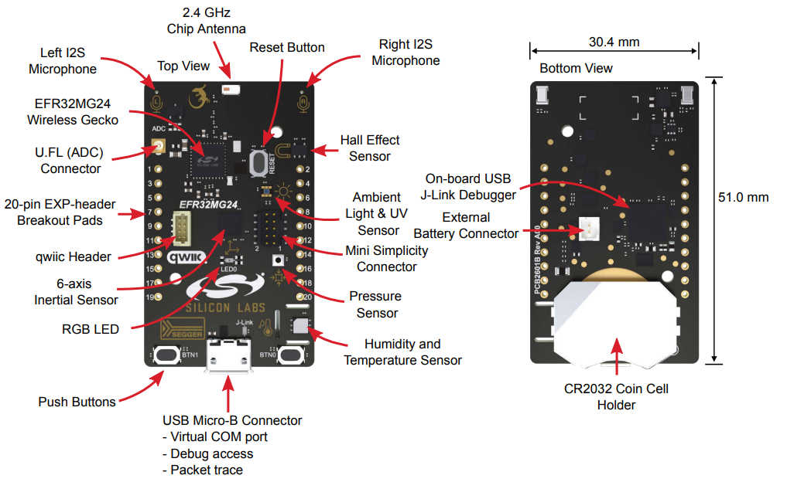
Figure1.1 from xG24Dev Kit User’s Guide

Features:
- 2.4 GHz ceramic chip antenna
- Humidity and temperature sensor
- Ambient light sensor
- Hall effect sensor
- 6-axis inertial sensor
- MEMS stereo microphones
- Pressure sensor
- RGB LED and two push buttons
- 20-pin 2.54 mm breakout pads
- Qwiic® connector
- Virtual COM port
- USB or coin cell battery powered
- External battery connector

Peripherals:
All peripherals have enable signals which can turn each peripheral on and off when not in use. Or a peripheral can be put into a state that draws minimal power.

The Si7021 humidity and temperature sensor utilizes the I2C interface.

The Si7210 hall effect sensor utilizes the I2C interface. The sensor applications range from mechanical position sensing, reed switch replacement, fluid level measurement, speed sensing, and control knobs, and switches.

The ICS-43434 microphones are omnidirectional MEMS microphones with a wideband frequency response and utilize the I2S interface.

The ICM-20689 6-axis inertial sensor consists of a 3-axis gyroscope and a 3-axis accelerometer. This sensor utilizes the SPI interface.

The VEML6035 ambient light sensor utilizes a I 2C digital interface. This interface is connected to the EFR32MG24 I2C bus. The I2C bus is shared with the Qwiic Connector and is also exported on the breakout pads.

The BMP384 pressure sensor/temperature sensor utilizes a digital interface supporting both SPI and I2C. The I2C is also connected to the EFR32MG24 I2C bus.

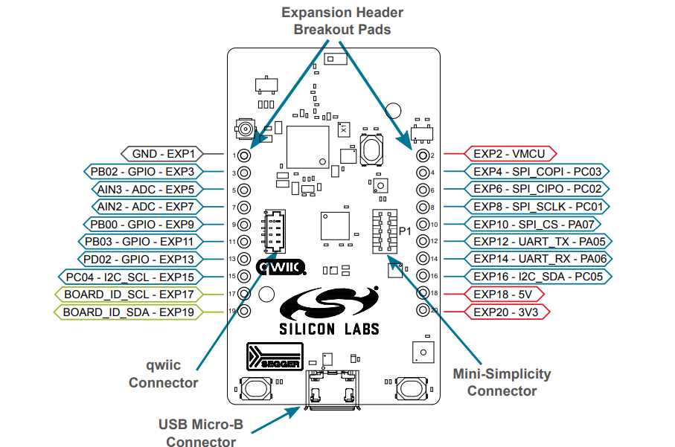
Figure 3.16 from xG24Dev Kit User’s Guide

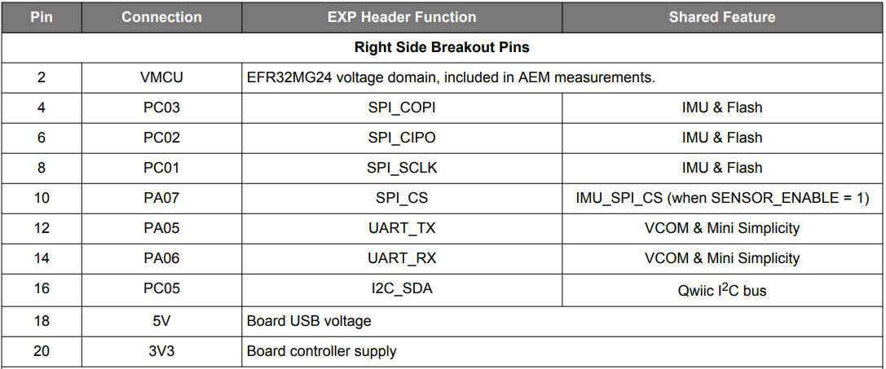
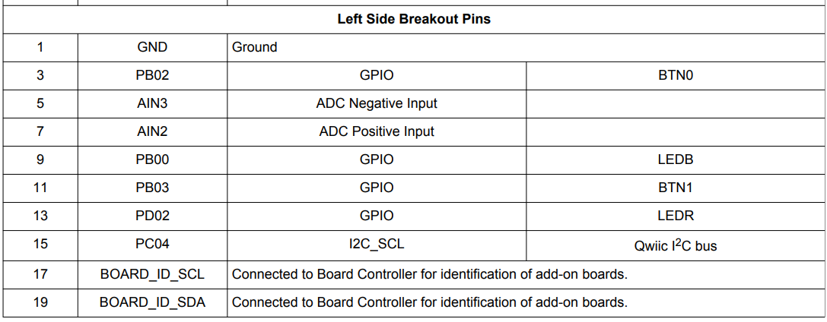
Table 3.2 from xG24Dev Kit User’s Guide

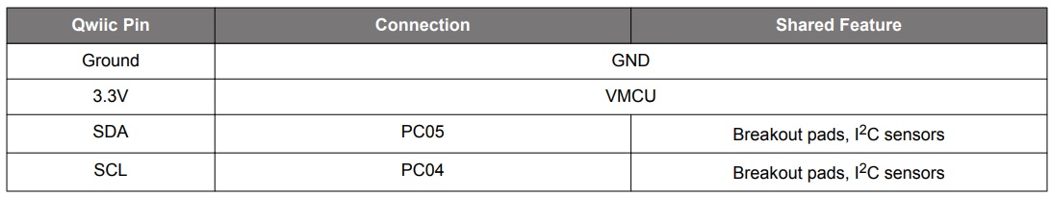
Table 3.3 from xG24Dev Kit User’s Guide

The Qwiic connector is compatible with Qwiic Connect System hardware. Can be used to expand the functionality of the xG24 Dev Kit with additional sensors, LCD’s and other peripherals that utilize the I2C interface.

Sources: https://www.silabs.com/documents/public/user-guides/ug524-brd2601b-user-guide.pdf

